# Using DM script framework for end point detection in PIPS/Ilion

Thijs Hosman, November 12, 2013

## Introduction

This DM addon will allow PIPS/Ilion users to terminate milling depending on the properties of the image that gets recorded every rotation. It also allows users to determine what parameters to use for termination by using pre-recorded images.

As of now, 2 scripts are included.

ROIIntensityPixels.s : detects dark area (ie perforation) or bright area (ie hole illuminated by PIPS bottom illuminator) of variable size within a user defined region of interest and terminates milling.

ROIIntensityAve.s : terminates milling when the average intensity in a user defined region of interest has changed by a variable percentage

Later, more scripts will be added (fringe detection, termination based on a perforation hitting a glue line) that can be operated the same way.

## Installing scripts

The scripts need to be installed before they can be used.

Open DM

Go to file > install script file

Select SpecPrepTermination.s

**(It is important that this script gets installed first)**

Select the Library tab and press ok.

Go to file > install script file

Select SpecPrepTerminationWelcome.s

This time, select the Menu Command tab and press ok.

For every terminate script (in this case ROIIntensityPixels.s and ROIIntensityAve.s), go to ‘file > install script file’ and install them **as a Library** (by going to the library tab and pressing ok)

Now, the scripts are installed and can be used. A menu item has been created under the Custom tab.

## Using Pre-Recorded Data to test scripts

The scripts will output useful information about termination in the DM output window. You can open the output window by going to Window > Show Output Window.

Go to the slice player window (if the slice player is not opened yet, go to Window > Floating Window > SlicePlayer) and press the Load From Files button. Go to the First file in a directory of recorded data and click open. Select the image window.

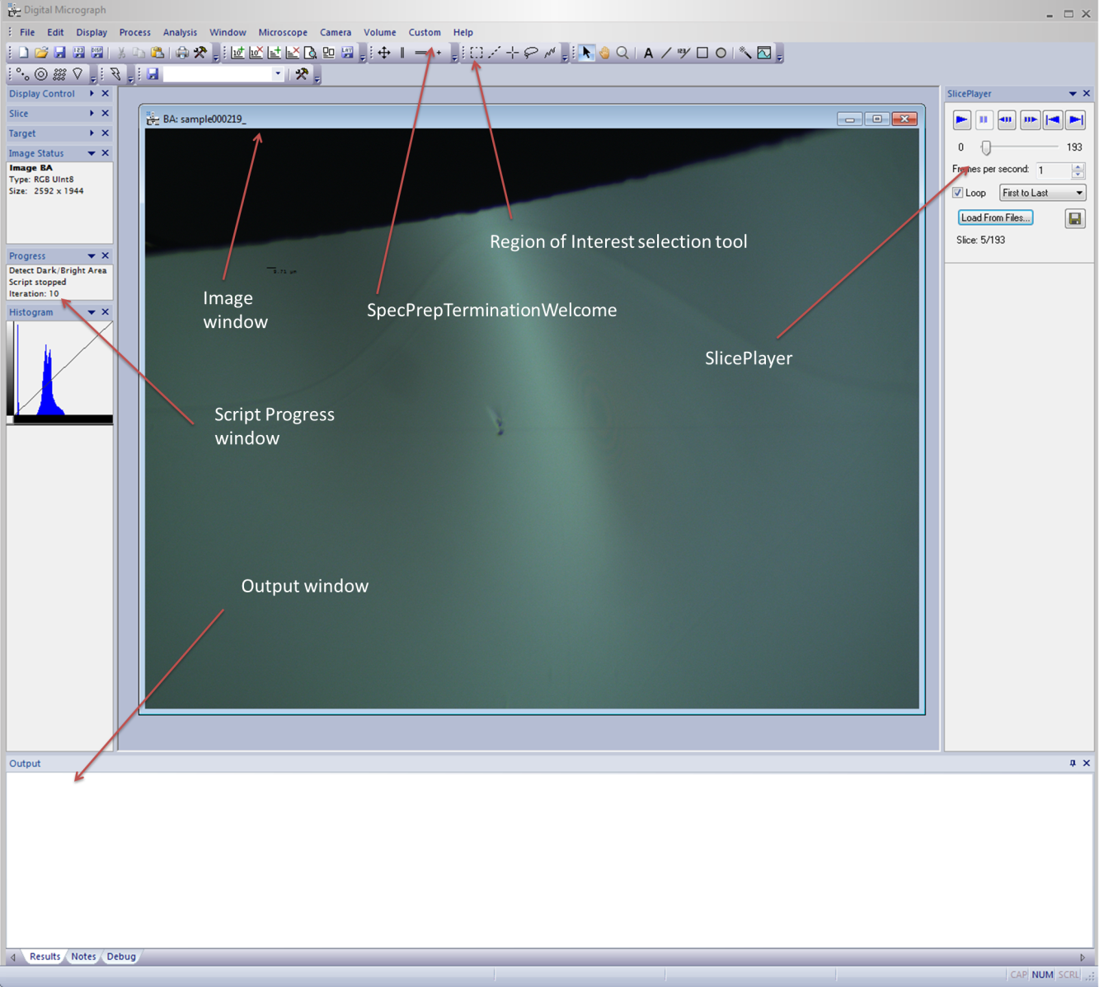

Now, go to Custom > SpecPrepTerminationWelcome. It prompts a window that asks you what script to run. Select a script, press start and the next window asks you to draw a region of interest in the image window (using the region of interest selection tool on the toolbar) and what the termination parameters are. When you press Run, the script starts running and detects changes in the image. You can use the sliceplayer to browse through the image slices one by one. The progress window tells you what scripts you selected, what it is doing and how many times the window is updated (iterations) and the output window gives information when the script terminates.

## Using Termination Scripts with PIPS/Ilion

In the Ion Polish window, select Record Milling and make sure the camera settings are correct (exposure, illuminator intensity, field of view). Start the milling process and make sure the image is updated. Now, you can start the script from the Custom > SpecPrepTerminationWelcome menu the same way as for pre-recorded data.